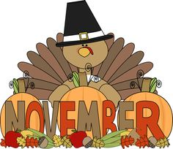

Month of November
Sunday | Monday | Tuesday | Wednesday | Thursday | Friday | Saturday
1  Tuition  Due | 2 | 3  Layla | 4  Destiny | 5 | 6  PETER PAN  MUSICAL  (Dress fancy!)  Ariana | 7
8 | 9  Dominic | 10  Gael | 11  Veteran’s Day  No school | 12  Destiny | 13  Hot Lunch | 14
15 | 16  Emilio | 17 | 18  Layla | 19  Ariana | 20  Hot Lunch | 21
22 | 23  Dominic | 24  Thanksgiving  Play & Dinner  6:00 | 25  No School | 26  No School | 27  No School | 28
29 | 30  Gael

